- What is the difference between Sleep, Hibernate, and Hybrid Sleep?

Sleep is a power-saving state that allows a computer to quickly resume full-power operation (typically within several seconds) when you want to start working again. Putting your computer into the sleep state is like pausing a DVD player—the computer immediately stops what it’s doing and is ready to start again when you want to resume working.

Hibernation is a power-saving state designed primarily for laptops. While sleep puts your work and settings in memory and draws a small amount of power, hibernation puts your open documents and programs on your hard disk, and then turns off your computer. Of all the power-saving states in Windows, hibernation uses the least amount of power. On a laptop, use hibernation when you know that you won't use your laptop for an extended period and won't have an opportunity to charge the battery during that time.

Hybrid sleep is designed primarily for desktop computers. Hybrid sleep is a combination of sleep and hibernate; it puts any open documents and programs in memory and on your hard disk, and then puts your computer into a low-power state so that you can quickly resume your work. That way, if a power failure occurs, Windows can restore your work from your hard disk. When hybrid sleep is turned on, putting your computer into sleep automatically puts your computer into hybrid sleep. Hybrid sleep is typically turned on by default on desktop computers.

- How can I wake my computer from hibernation?

On most computers, you can resume working by pressing your computer's power button. However, not all computers are the same. You might be able to wake your computer by pressing any key on the keyboard, clicking a mouse button, or opening the lid on a laptop.

You can also wake our computers by turning them on remotely over a network. This is called Remote Wake-up or Wake on LAN. This is how IT adds software updates and patches to our workstations.

The correct procedure for you as a user is to leave the computer powered on at all times. Make sure to “Log Off” whenever you leave it either during the day or at night when you leave to go home. I would also recommend that you do a full power off then back on once a week to clean up the cache and registers.

- What about the Roadway Design Computers?

As you know, we have both desktop and laptop workstations here in Roadway. Since the same image is used for both types, the “Power Setup” is the same for both. That is the display turns off after 30 minutes and the computer goes to “Sleep” after 90 minutes. These settings are supplied by the state IT group to preserve power and allow the workstation to be updated at automatically at night if needed when we are away.

Laptops are a bit different though (see the figure below). They have TWO sets of power settings based on whether they are being supplied AC power or getting their power from their battery. Note that the “Plugged In” settings are identical to the setting you would see on a desktop workstation.

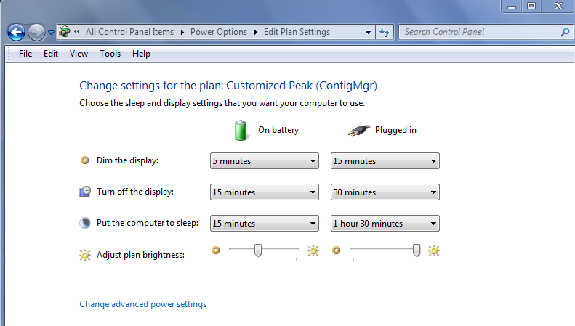

- Can these power settings be changed?

Yes they can but I would strongly recommend that they be left as set unless there is a need to change them. If you want them changed, please see the support group before changing them.

